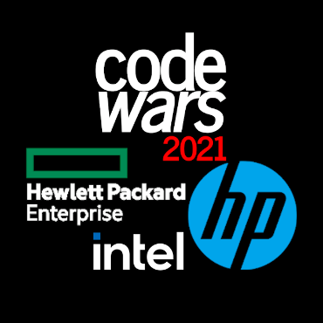

HPE

**CodeWars System**

**User Guide (English Version)**

**CodeWars System User Guide**

1. System Login 3
2. Team Dashboard 5
3. Problems and Submission 6
   1. Problem Descriptions 6
   2. Select a Programming Language 8
   3. Start programming 9
   4. Verify Your Codes 10
   5. Submit Your Program 11
4. Checking your scores 13
5. System Message 14

2

# System Login

Test environment link: <https://competition.hpcodewars.com.tw/>

Please be aware:

Microsoft Internet Explorer is not supported on CodeWars System 2.0. Supported Browser for Online Coding Platform:

* + Microsoft Edge 25.10 or newer
  + Google Chrome 56 or newer
  + Apple Safari 10.0.2 or newer
  + Mozilla Firefox 50 or newer
  + Microsoft Internet Explorer is not supported on our Online Coding Platform. Welcome to CodeWars system. Press Ready and let’s start challenging!

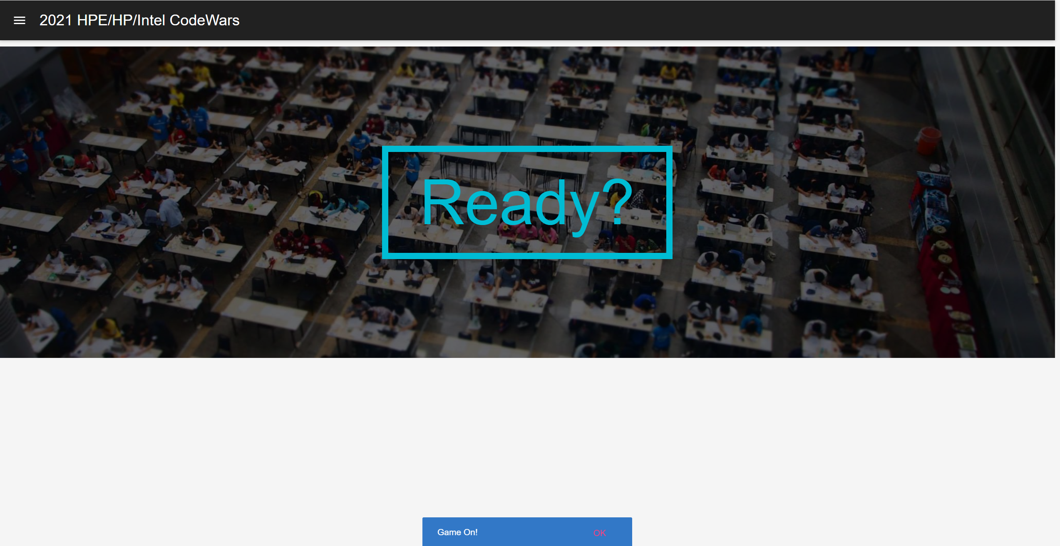

Enter your” User Name” and “Password”. Press GO to log in the system.

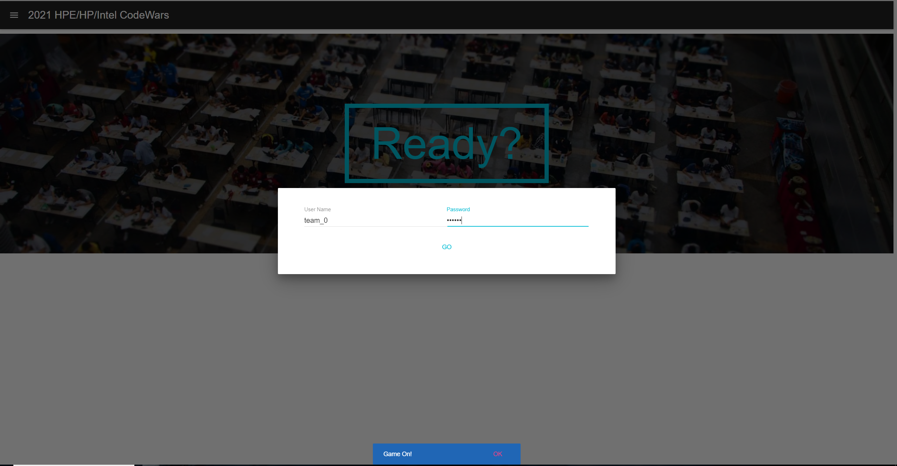

1. **Dashboard**

While you enter the team dashboard, you will see the game start remaining time.

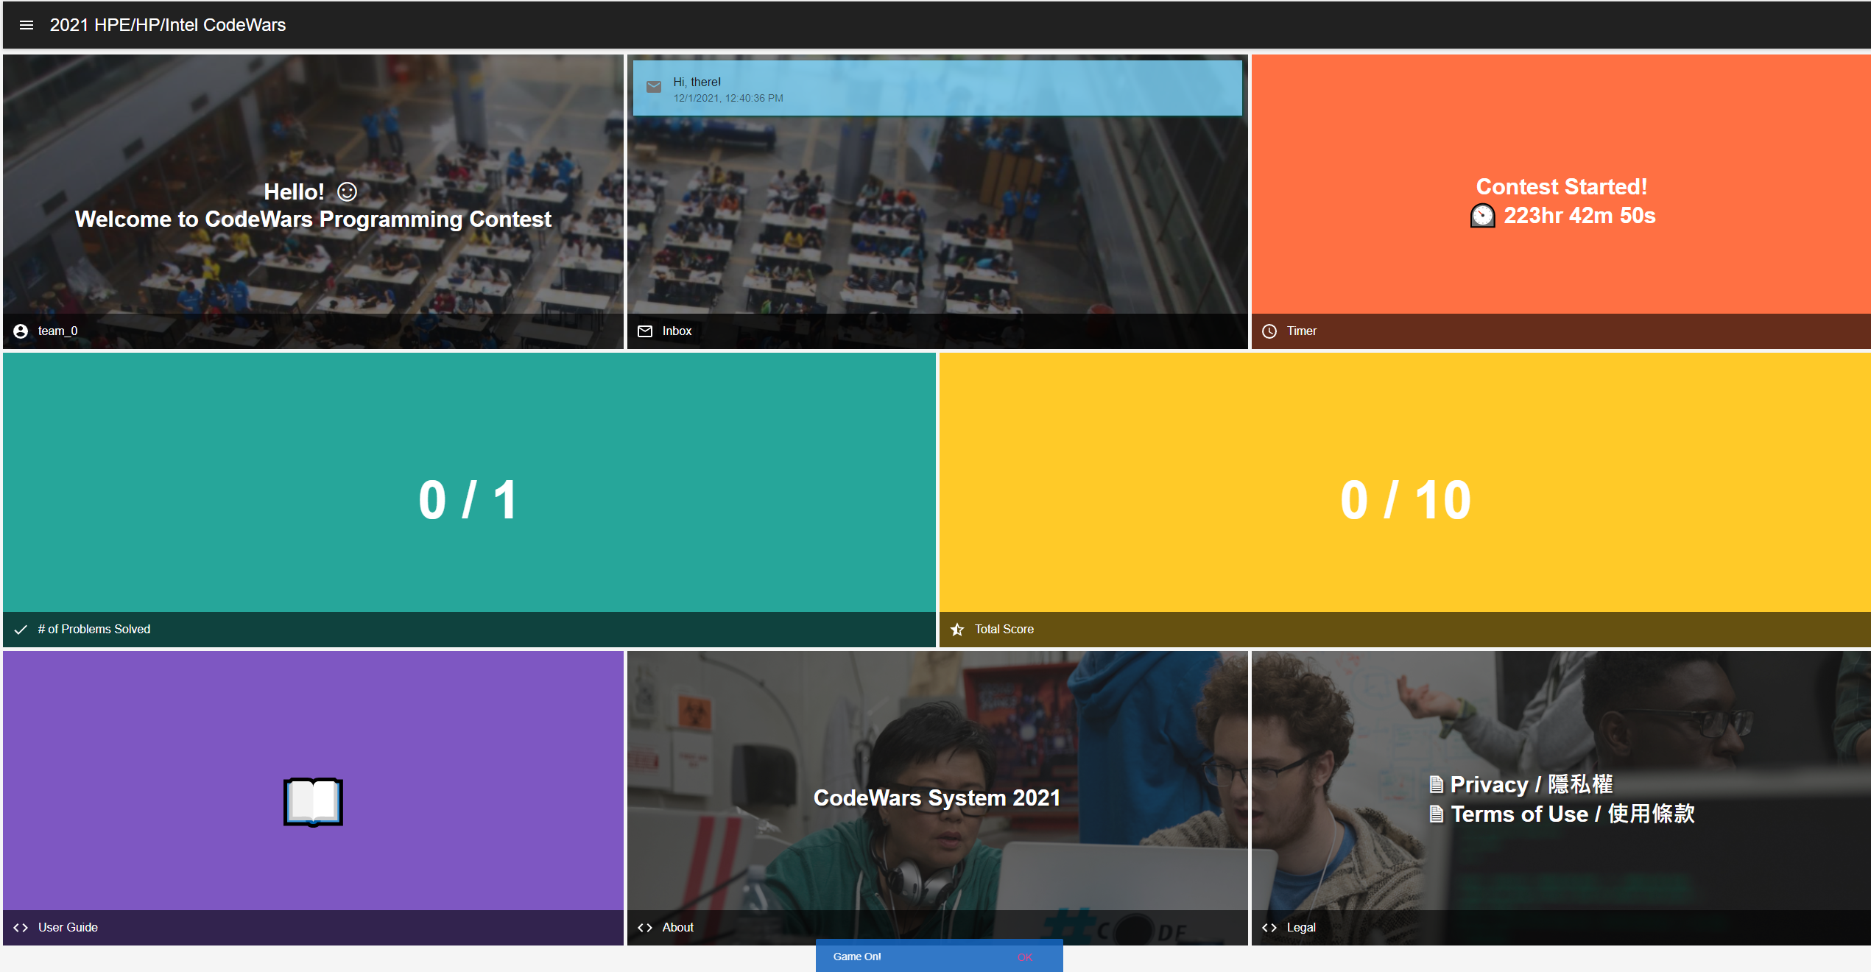

You also can see some competition information in the dashboard. You can click the upper left corner button with this icon  to see the problem list. Before the game on, you will not see the problems.

# Problems and Submission

## Problem Descriptions

**Game remaining time**

You can see the problems list and each score after the game on.



**Your current passed problems**

**Your current scores**

Choose a problem, click it and start challenging.

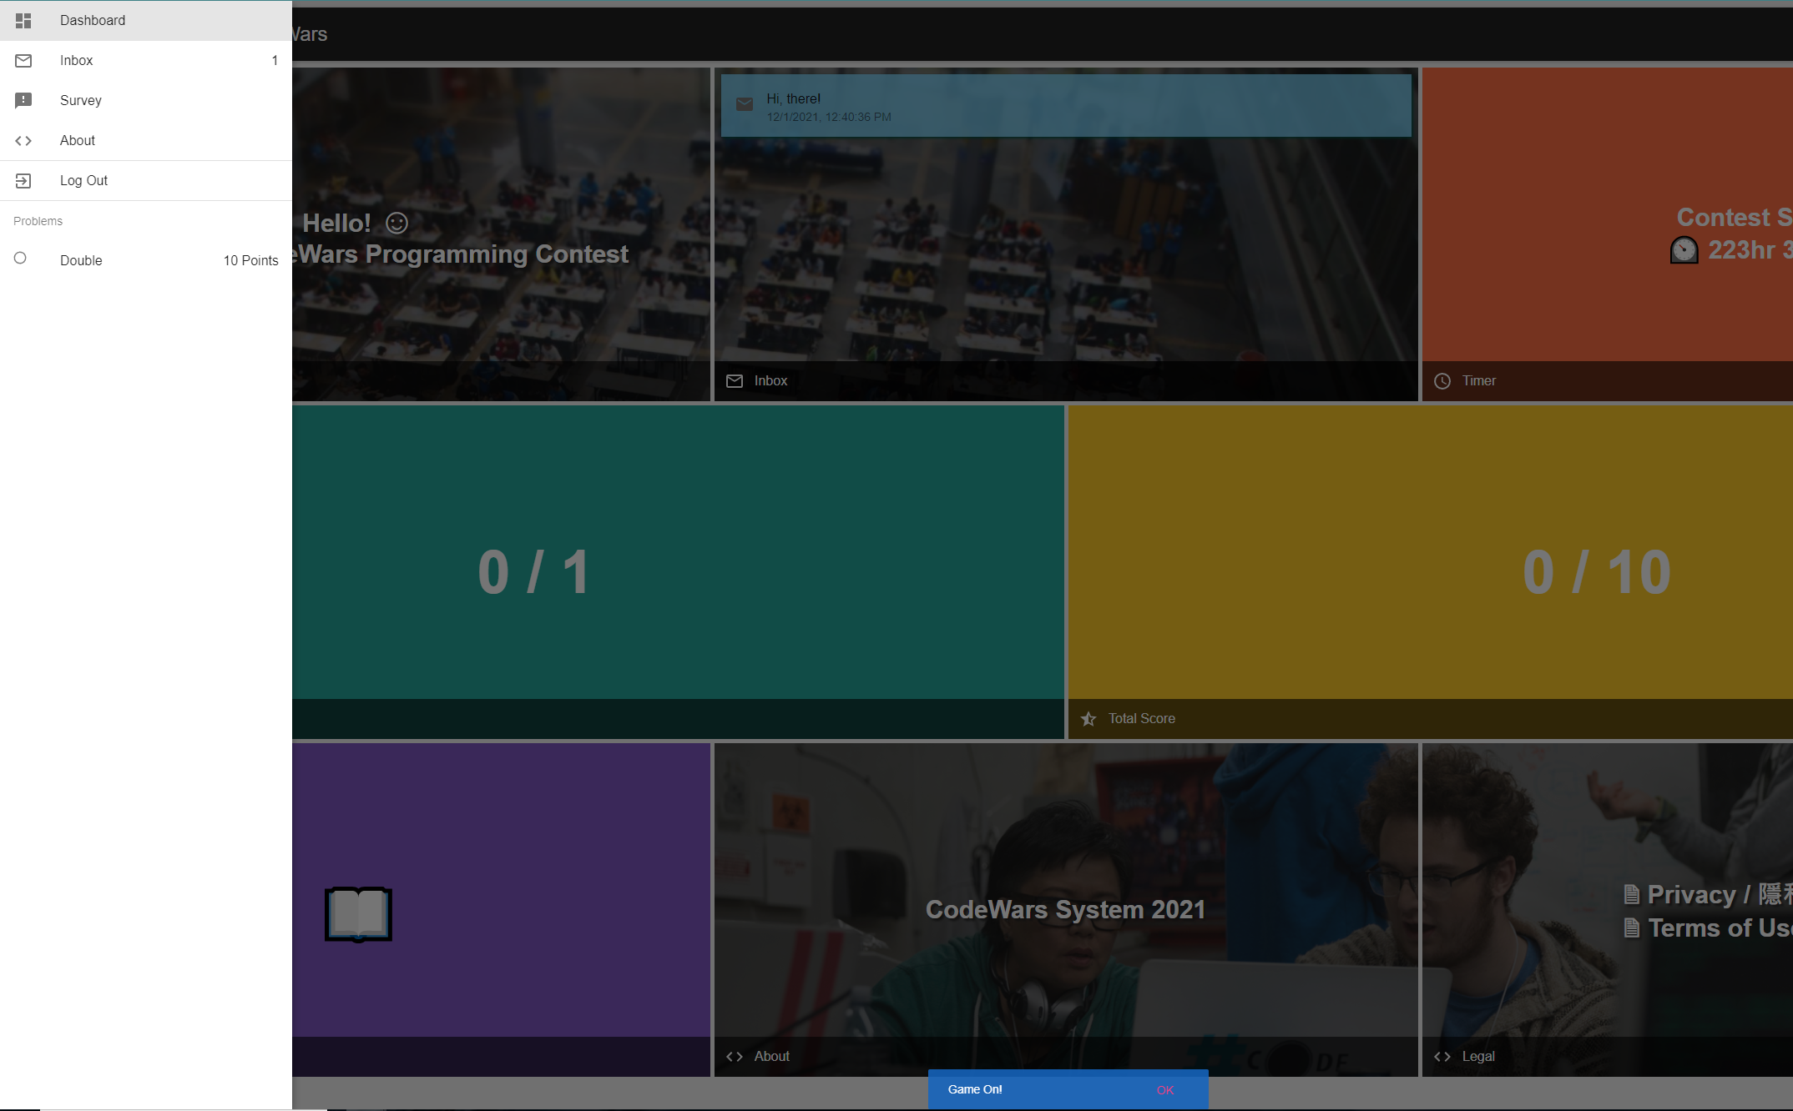

After picking up a problem, you will enter the problem page. You can see all problem information right now.

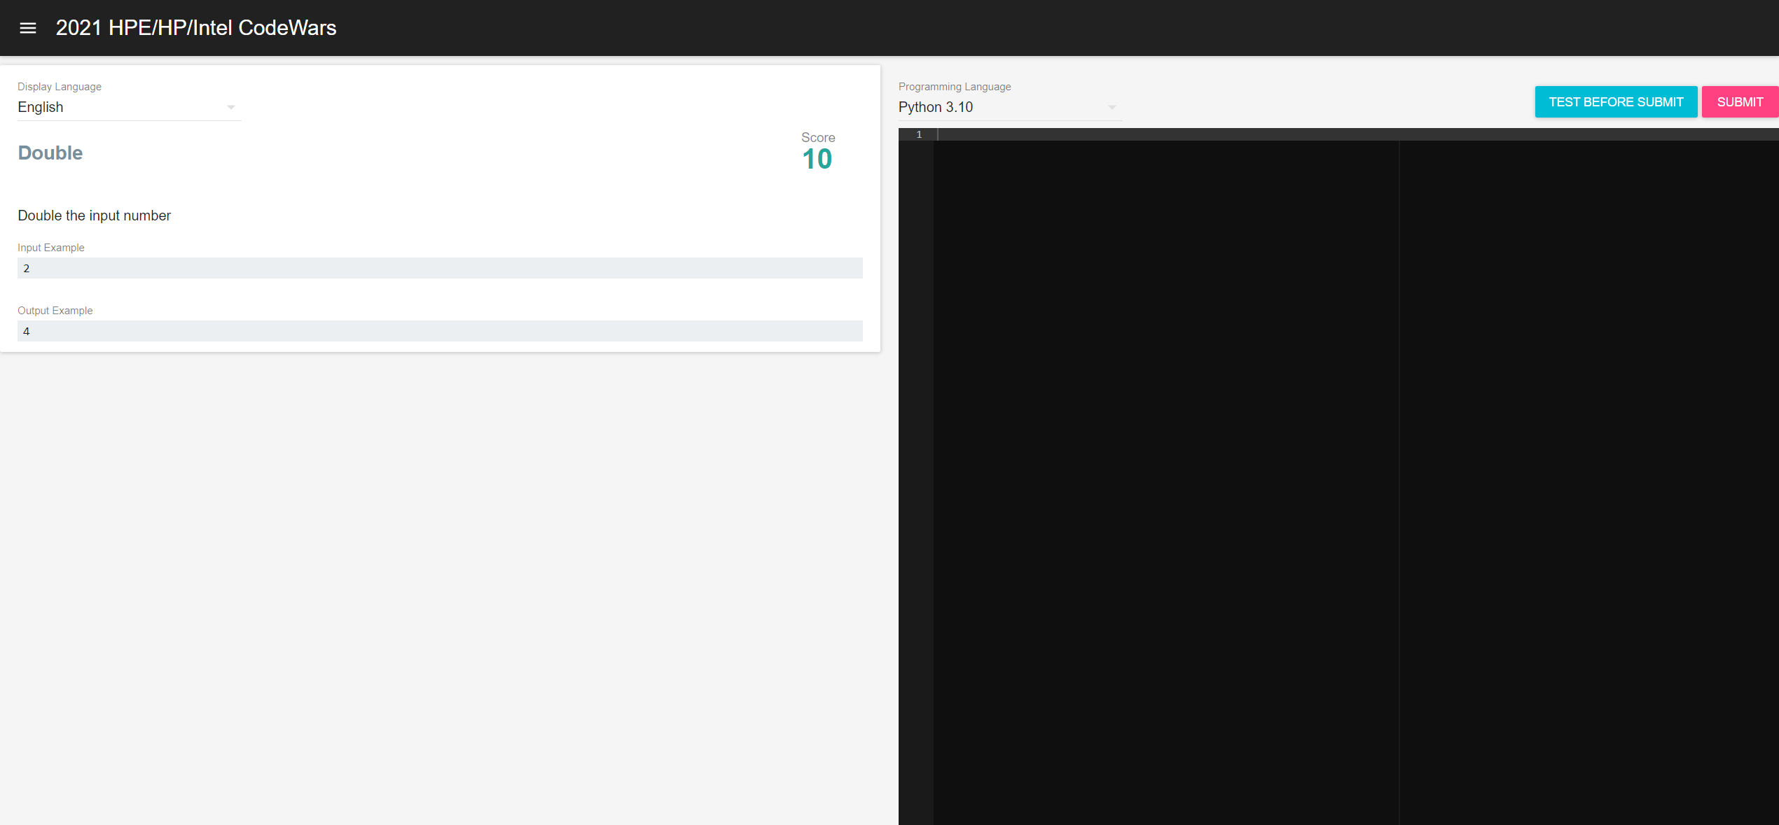

**Output**

**Input**

**Problem Description**

## Select a Programming Language

Select one programming language you would like to challenge via click

“Language” drop menu.

For example,

For example, let’s choose Python3 to challenge.

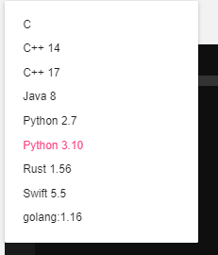

Please be aware, the problem code is run on Linux and that the input is given to the program via standard input (stdin).

## Start programming

After selecting your programming language, you can start to write you program within the programming area.



**Programming Area**

## Verify Your Codes

CodeWars 2.0 provides program verification function. Before you submit your program, you can use this function to verify the correctness of your program. Please press “TEST BEFORE SUBMIT” button to see the result.

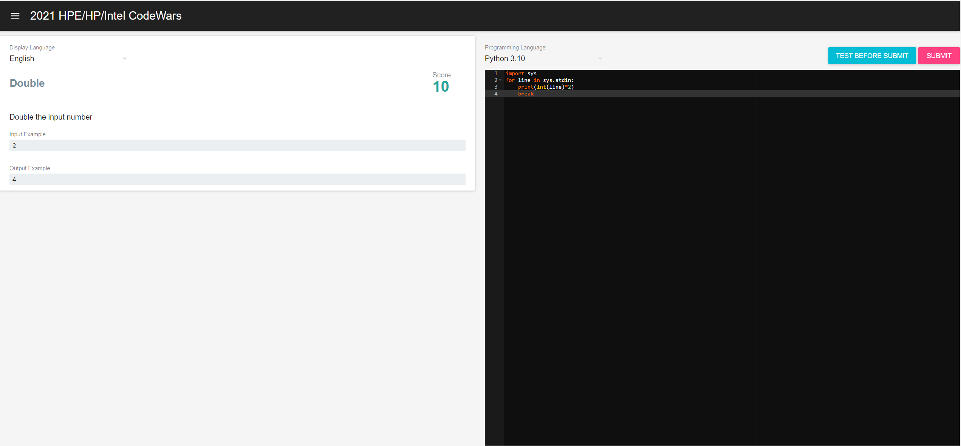

If you pass the example test, you can see the following message

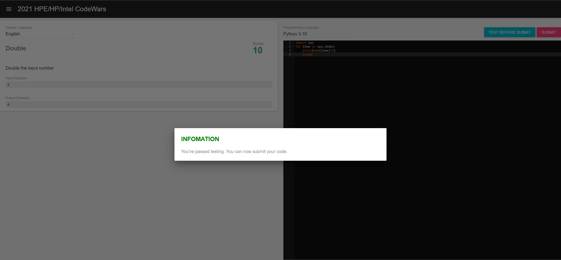

## Submit Your Program

After you have passed testing, you can press “SUBMIT” button to submit your

program.



If your submission is correct, you can see the following message.

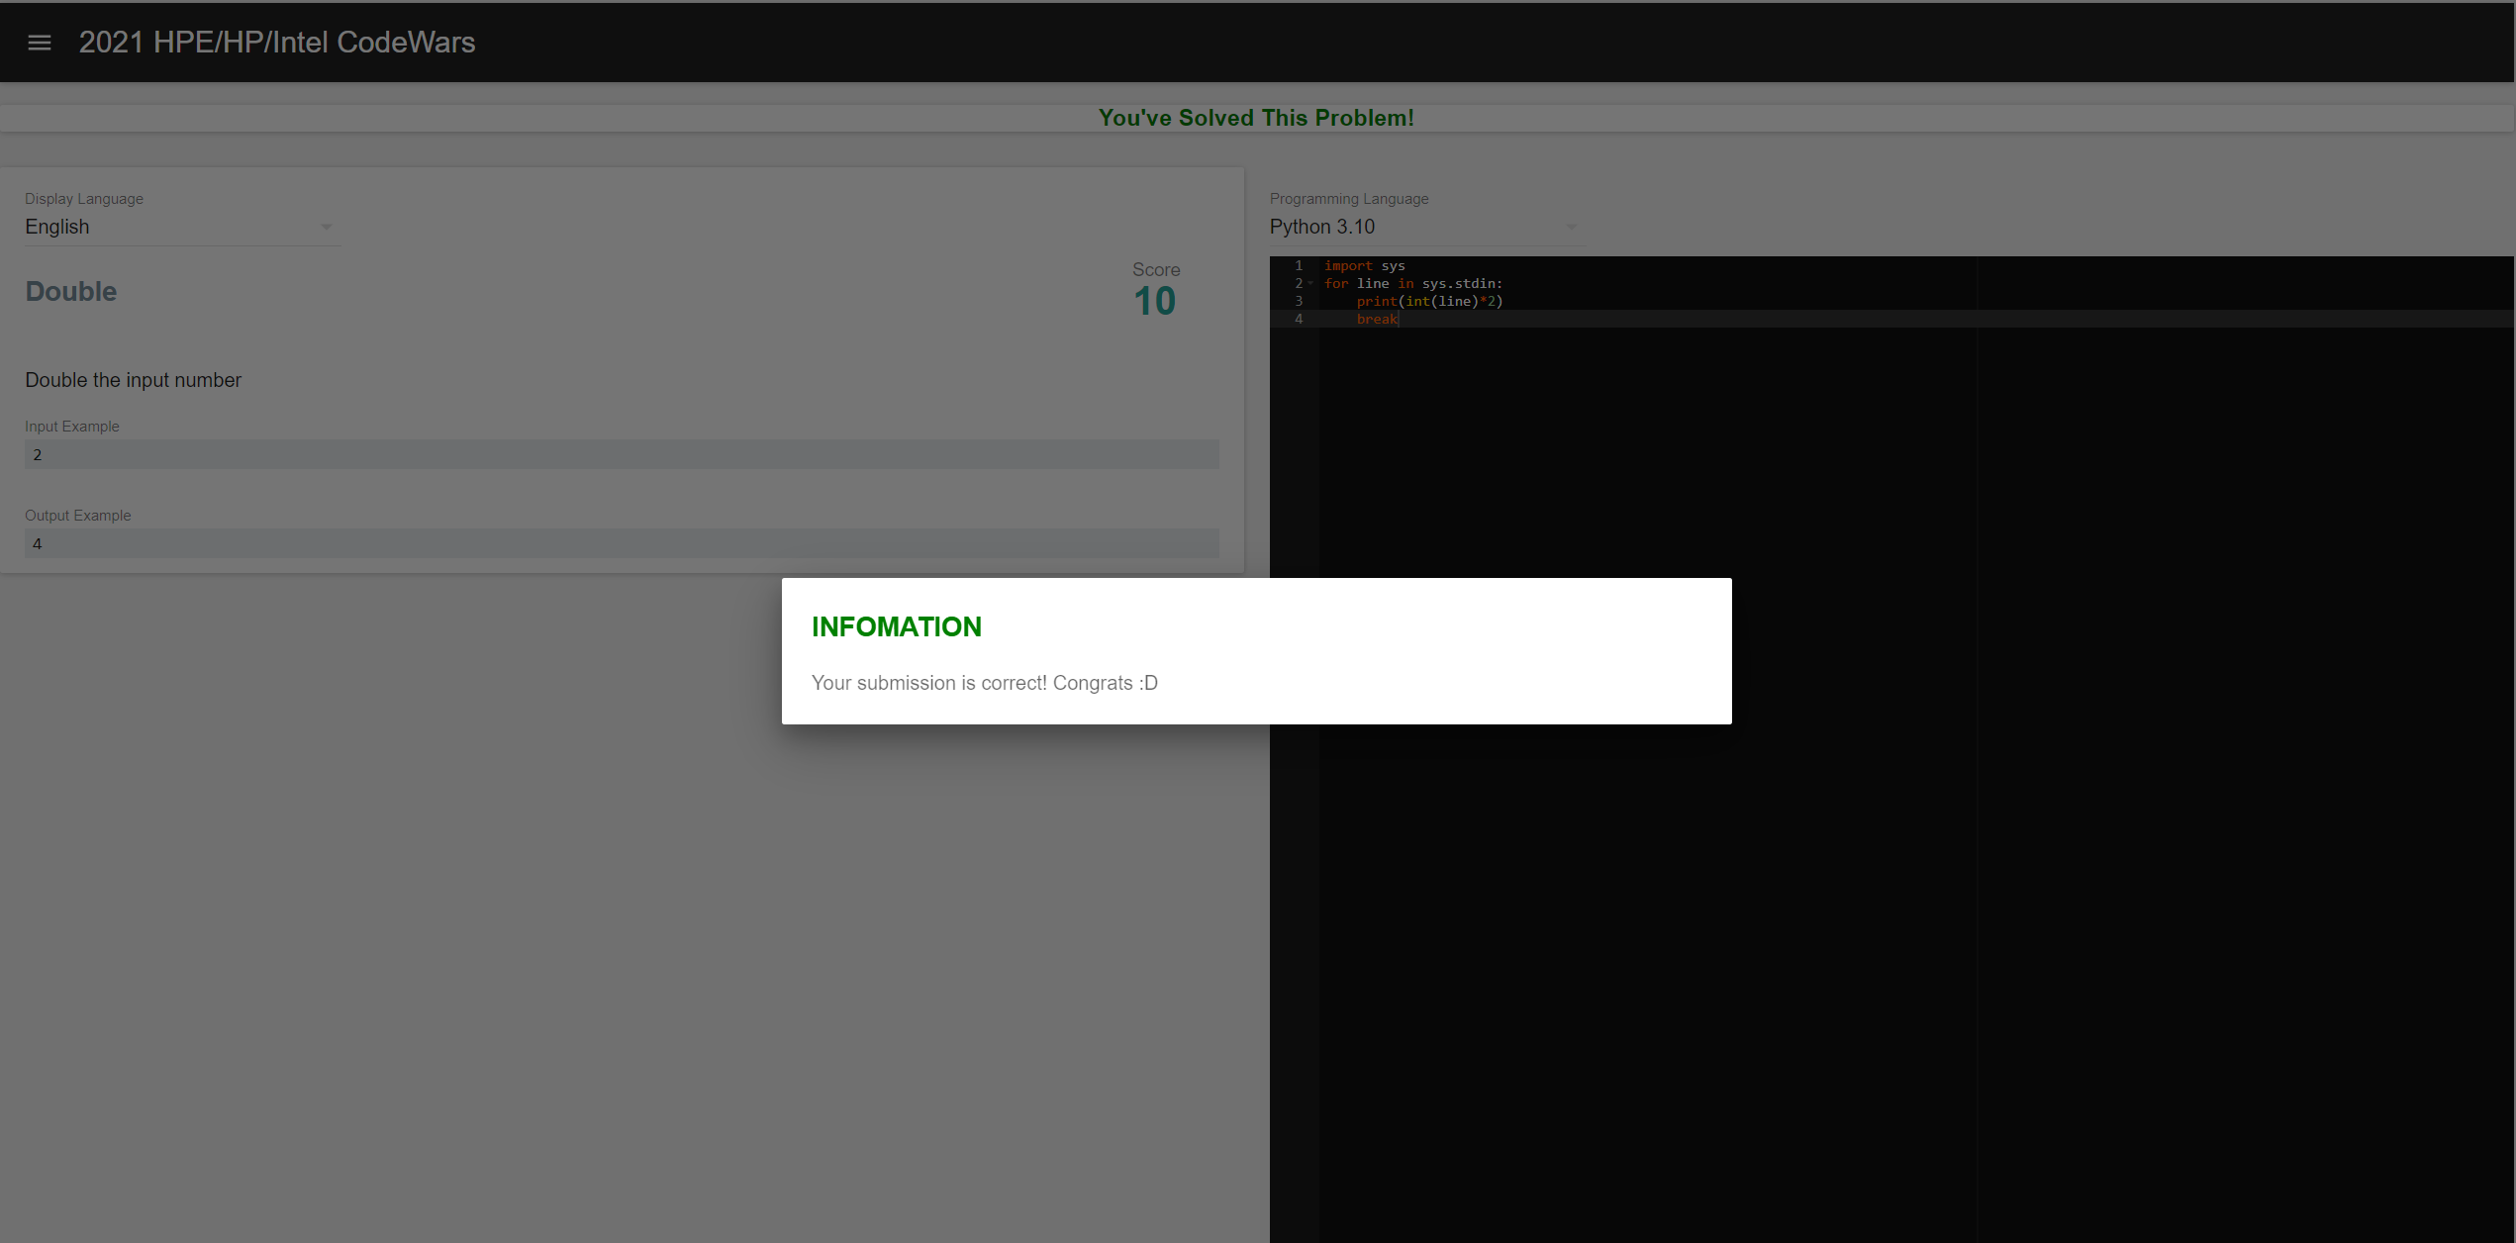

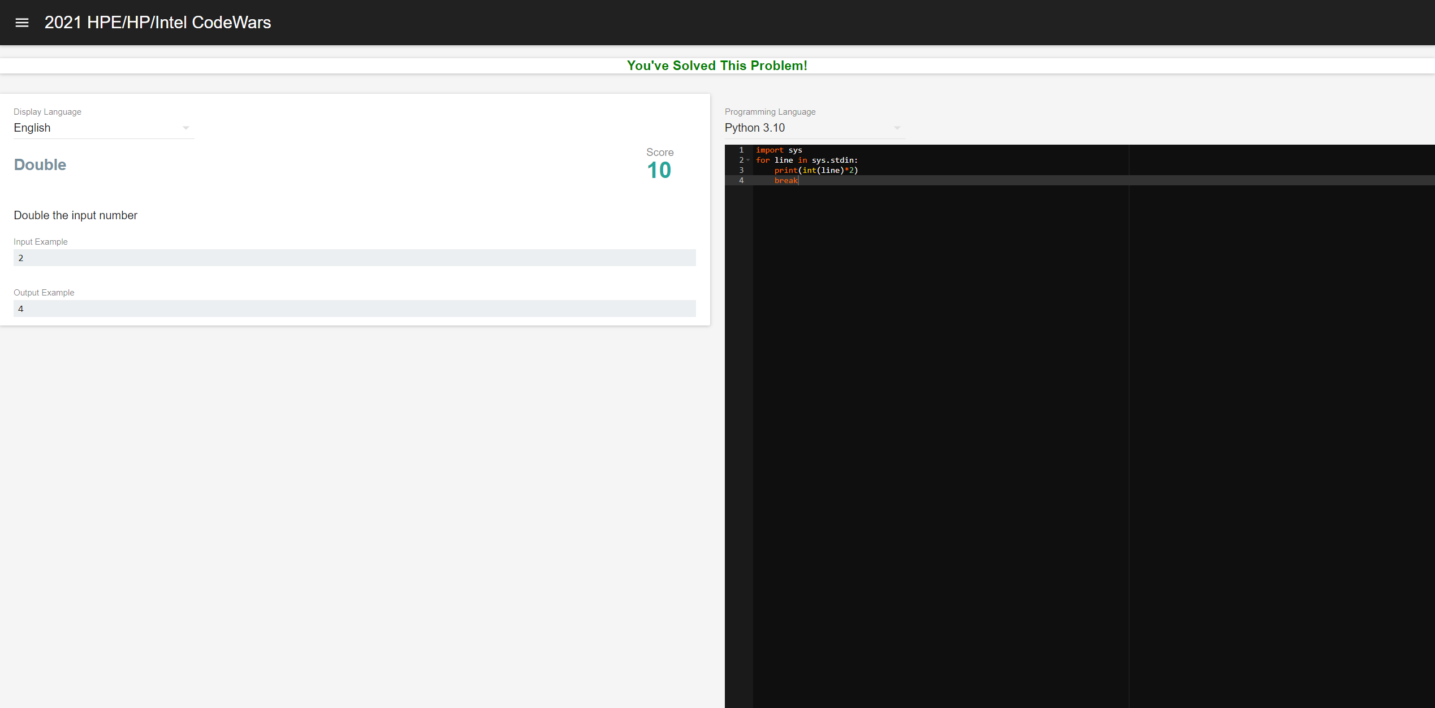

**Congratulation! You solve the problem.**

Click the upper left corner button with this icon , you will see there is a green check shows the problem is solved successfully.

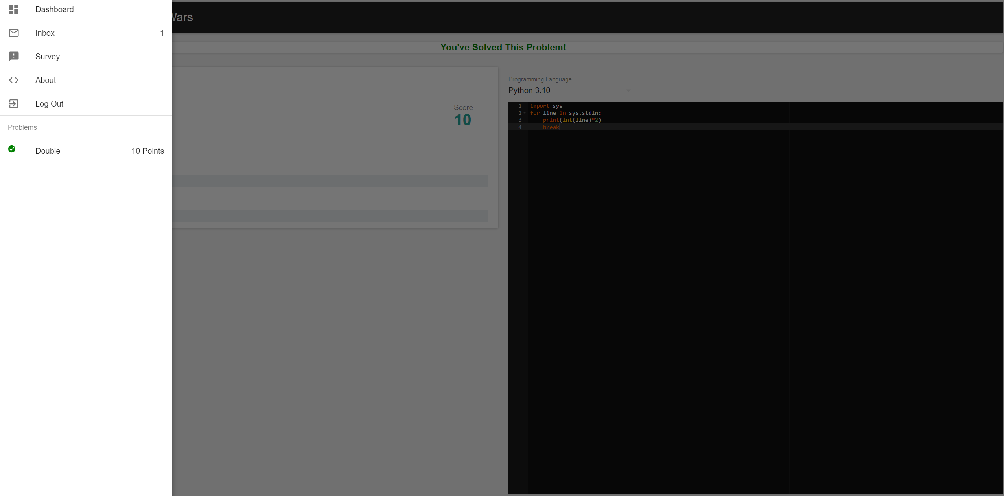

# Checking your scores

Choose “Dashboard” to back to team dashboard and see your current scores.



WOW, you have completed one problem, and your current score is 10. Let’s keep

going.

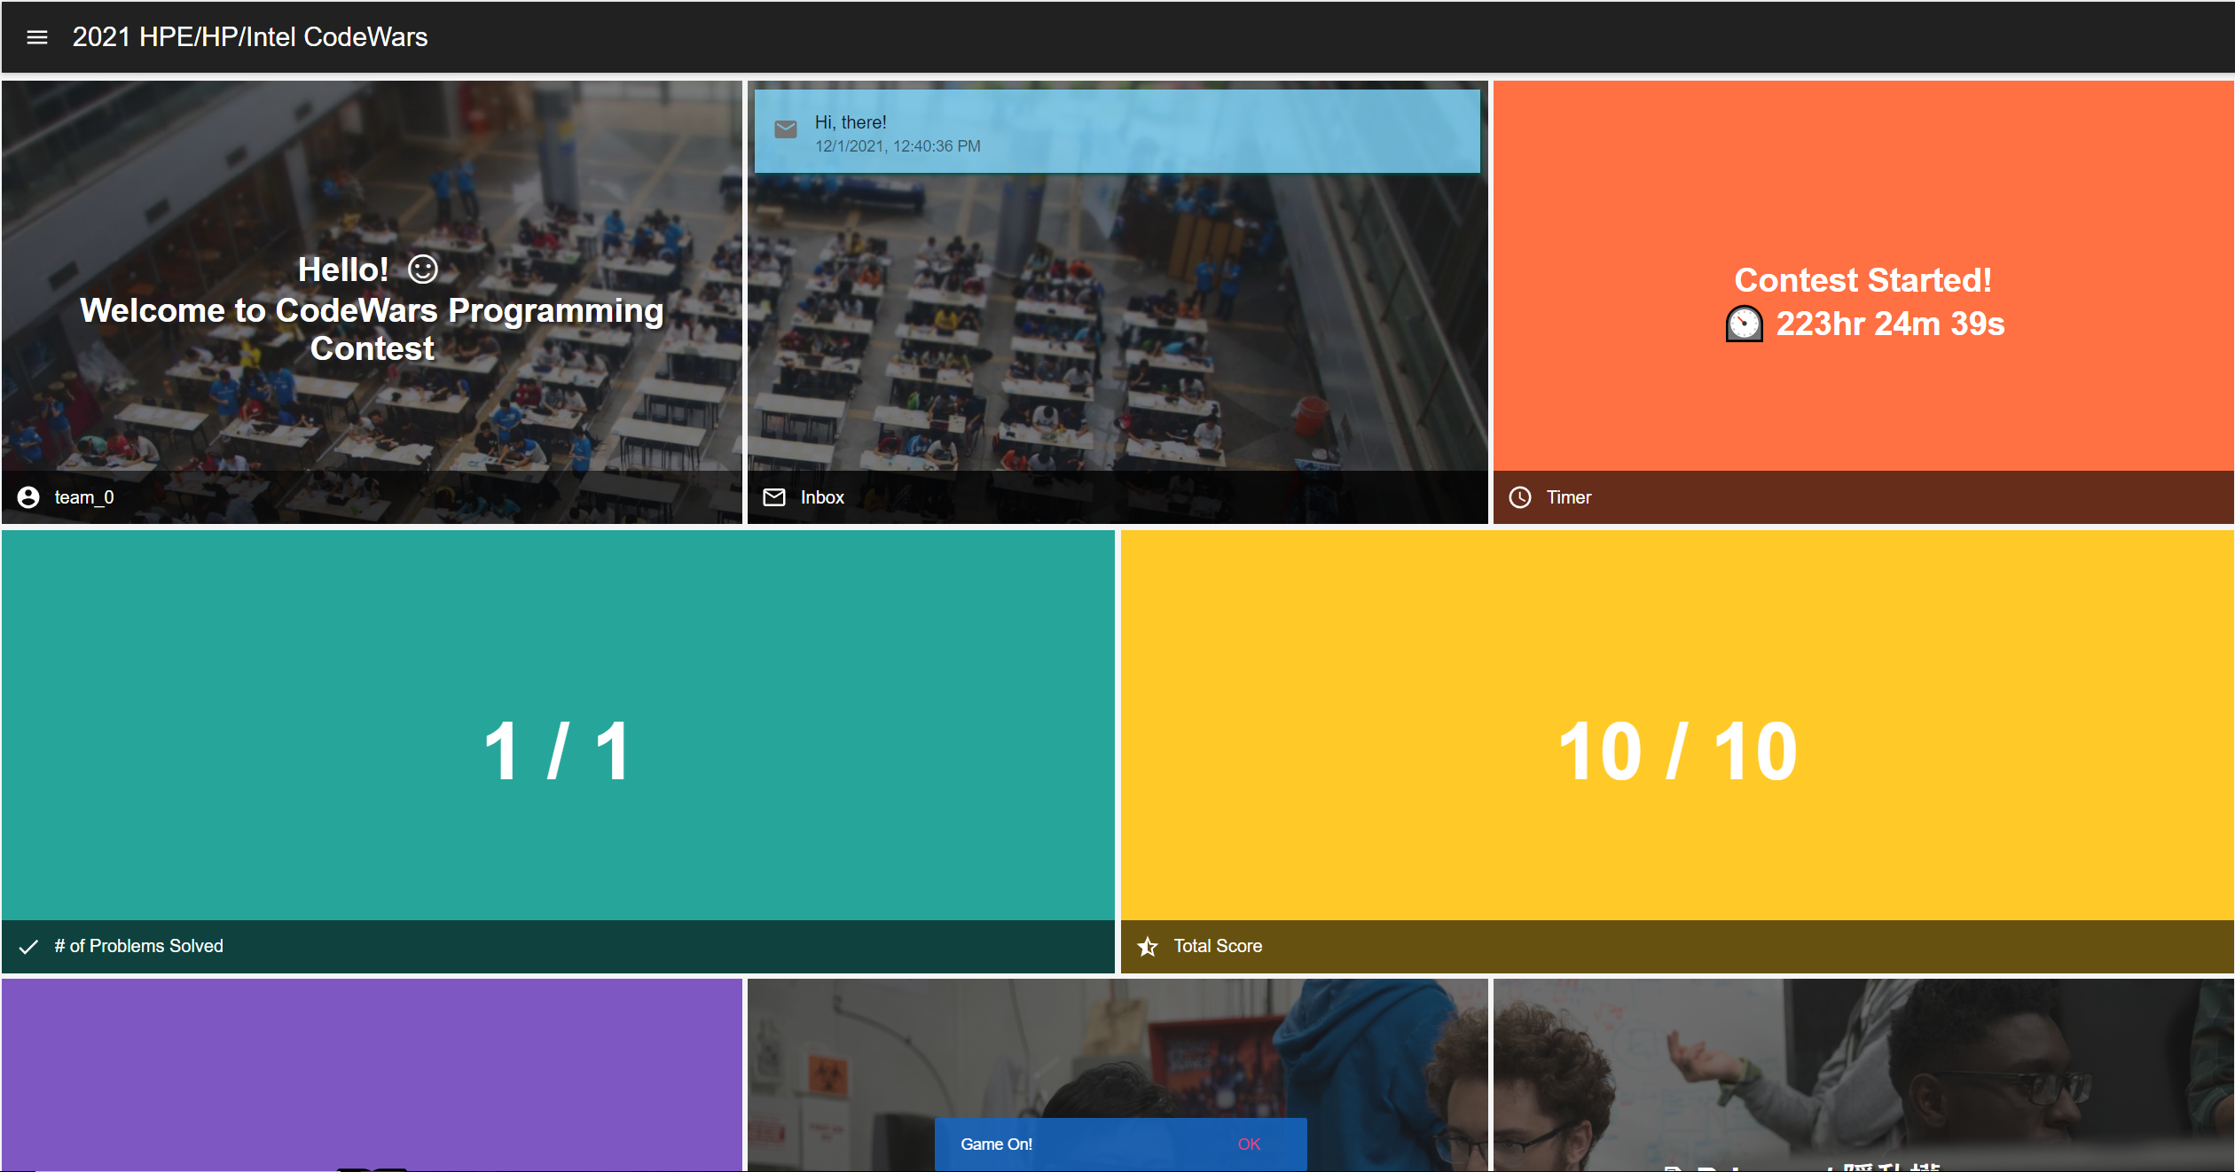

# System Message

CodeWars Team will announce message via text message. You will see the message

notification below the Dashboard. Click “OK” to release the notification.



You also can see the message in the middle square of the dashboard. Click it and read the message in detail.

